علم النبات
ا.م د . قاسم جاسم عذافه
دراسات عليا ماجستير
.
‏

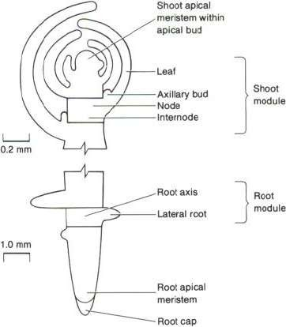
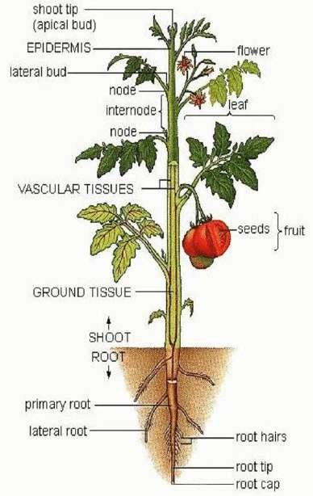

What is Plant Taxonomy: It’s a field of science that includes Description, Identification, Nomenclature, and Classification Plant Systematic.
النص هنا

**Classification: It’s the arrangement of taxa into some type of order, the purpose of this field is to provide a system for cataloguing and expressing relationships between these taxa.
**Taxon: It’s a group of organisms typically treated at a given rank
Major taxonomic ranks:
Ranks Taxa
Divison
Sub divison
Class
Order
Family
Genus
Species

Characters used for plant classification:
1- Morphological data :- a/ Micromorphology b/ Gross morphology
2- Presence or absence of certain tissues and vegetative organs.
3- Similarity and dissimilarity of reproductive structure.
Classification Systems :
1- Artificial classification :- It’s the first system which used one or few characters to classify plants.

2- Natural classification :- This system is based upon several to many characters selected for their value in positively correlating characters to form groups in ranks.

3- Phyletic or Evolutionary system of classification :- This system arise after the theory of evolution, which emphasizes on relationships by descent of the groups in their systems. The first clearly phyletic system of classification was produced by German botanist, August Wilhelm Eichler, he dealt with the entire plant kingdom. Another system was produced by Adolf Engler and Eugen Prantl based on Eichler system.

**Identification:- It’s the process of associating an unknown taxon with a known one or recognizing, plant taxa
** Nomenclature:- It’s the formal naming of taxa according to some standardized systems

-Plant cells

are eukaryotic cells with a true nucleus along with specialized structures called organelles that carry out certain specific functions.
*Plastids *Endoplasmic Reticulum *Golgi Apparatus
- Microfilaments * Microtubules *Mitochondria * Nucleus* Vacuole
- Peroxisomes * Plasmodesmata *Plasma Membrane *Ribosomes.
*Plasti
ds - The most important characteristic of plants is their ability to photosynthesize, in effect, to make their own food by converting light energy into chemical energy. This process is carried out in specialized organelles called chloroplasts.
*Endoplasmic Reticulum - The endoplasmic reticulum is a network of sacs that manufactures, processes, and transports chemical compounds for use inside and outside of the cell. It is connected to the double-layered nuclear envelope, providing a pipeline between the nucleus and the cytoplasm. In plants, the endoplasmic reticulum also connects between cells via the plasmodesmata.
*Golgi Apparatus - The Golgi apparatus is the distribution and shipping department for the cell's chemical products. It modifies proteins and fats built in the endoplasmic reticulum and prepares them for export as outside of the cell.

*Microfilaments - Microfilaments are solid rods made of globular proteins called actin. These filaments are primarily structural in function and are an important component of the cytoskeleton.
*Microtubules - These straight, hollow cylinders are found throughout the cytoplasm of all eukaryotic cells (prokaryotes don't have them) and carry out a variety of functions, ranging from transport to structural support.
*Mitochondria - Mitochondria are oblong shaped organelles found in the cytoplasm of all eukaryotic cells. In plant cells, they break down carbohydrate and sugar molecules to provide energy, particularly when light isn't available for the chloroplasts to produce energy.
*Nucleus - The nucleus is a highly specialized organelle that serves as the information processing and administrative center of the cell. This organelle has two major functions: it stores the cell's hereditary material,

or DNA, and it coordinates the cell's activities, which include growth intermediary metabolism, protein synthesis, and reproduction (cell division).
*Peroxisomes - Microbodies are a diverse group of organelles that are found in the cytoplasm, roughly spherical and bound by a single membrane. There are several types of microbodies but peroxisomes are the most common.
*Plasmodesmata - Plasmodesmata are small tubes that connect plant cells to each other, providing living bridges between cells.
*Plasma Membrane - All living cells have a plasma membrane that encloses their contents. In prokaryotes and plants, the membrane is the inner layer of protection surrounded by a rigid cell wall. These membranes also regulate the passage of molecules in and out of the cells.
*Ribosomes - All living cells contain ribosomes, tiny organelles composed of approximately 60 percent RNA and 40 percent protein. In eukaryotes, ribosomes are made of four strands of RNA. In prokaryotes, they consist of three strands of RNA.
*Vacuole - Each plant cell has a large, single vacuole that stores compounds, helps in plant growth, and plays an important structural role for the plant.
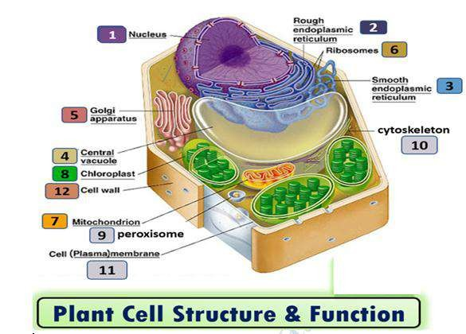

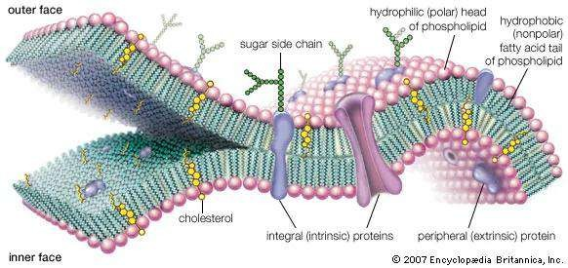

Plasma membrane structure
The plasma membrane is a structure of the plant cell that forms a semipermeable, or selective, barrier between the interior of the cell and the external environment; they also function in transport of molecules into and out of the cell.

In addition to forming the structural barrier between the internal contents of a cell and the external environment, plasma membranes contain proteins involved in the transport of molecules and other substances into and out of the cell, and they contain proteins and other molecules that are essential for receiving signals from the environment and from plant hormones that direct growth and division.
Carbohydrates associated with the plasma membrane are markers of cell type. In plants, the plasma membrane is the site of cellulose synthesis.

Phospholipids are the most abundant lipid of plasma membranes, and they are organized in a fluid phospholipid bilayer in which sterols, proteins, and other molecules are interspersed. Phospholipids are amphipathic molecules, containing water-loving (hydrophilic) regions and water-fearing (hydrophobic) regions.

Sterols found in plant cells are important economically as the starting material for steroid-based drugs.
Membrane Proteins and Carbohydrates

Some membrane proteins span the entire length of the phospholipid bilayer and are called trans membrane proteins. Trans membrane proteins are sometimes referred to as integral membrane proteins and have varied structures and functions.
Membrane proteins are often important for receiving signals from the external environment as membrane receptors.

Membrane proteins form pores that allow ions (charged particles) to pass through the interior of the membrane. Membrane proteins called carriers are essential for bringing nutrient molecules such as simple sugars into the cell.
Not all proteins within the membrane are trans membrane proteins. Some are only loosely associated with the membrane, attached to other proteins, or anchored in the membrane by a lipid tail. These proteins, which do not span both sides of the membrane, are often called peripheral membrane proteins.

In addition to proteins, the plasma membrane contains carbohydrate molecules. Carbohydrate molecules are usually attached to membrane proteins or to lipid molecules within the bilayer. Carbohydrates provide important information about cell type and identity.

Types of transport
- Channels- Passive transport
*Carriers-Passive/active transport

*Pumps- active transport

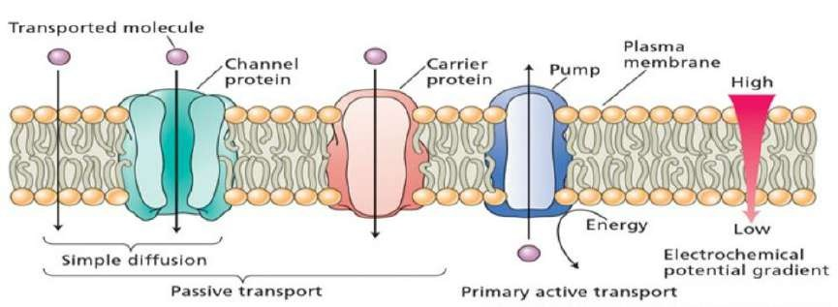

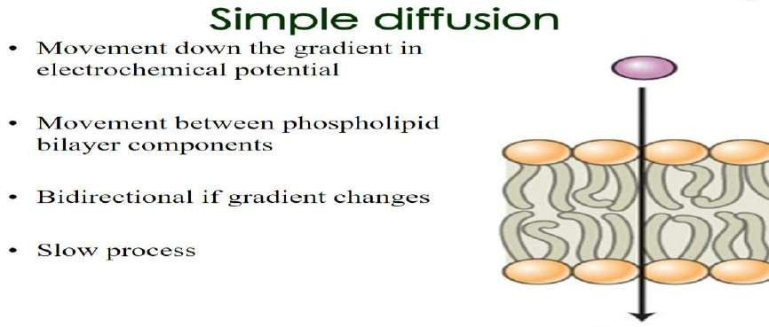
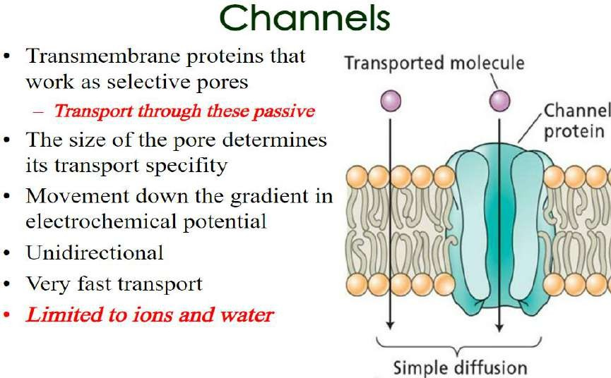

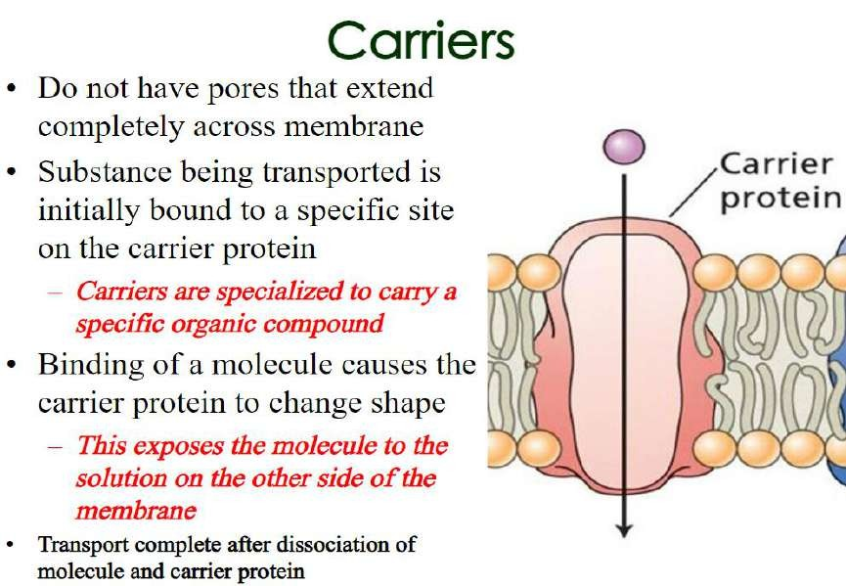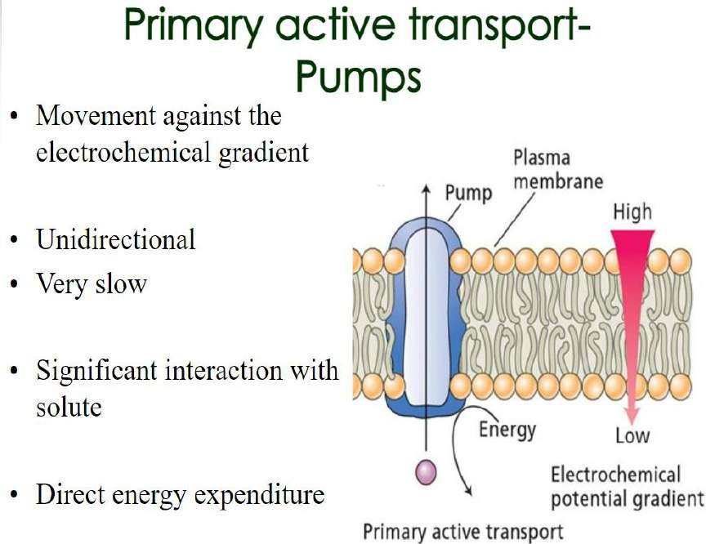

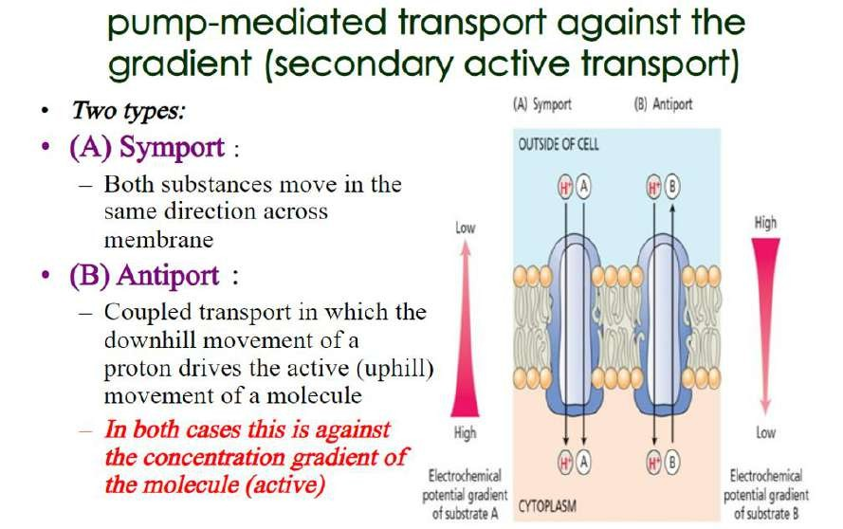

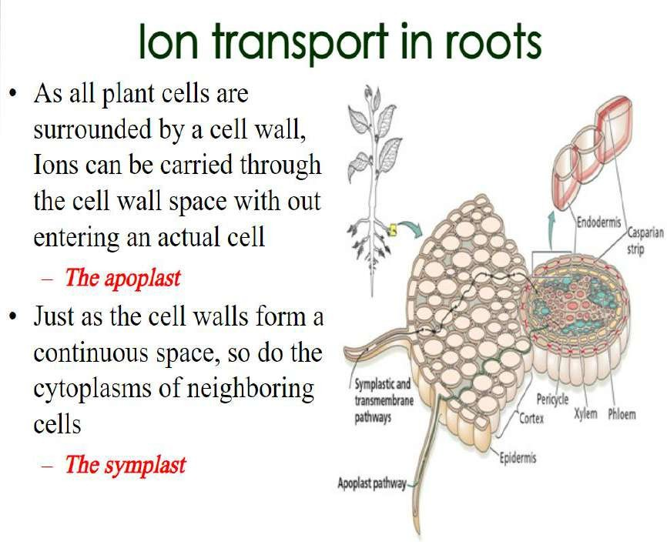

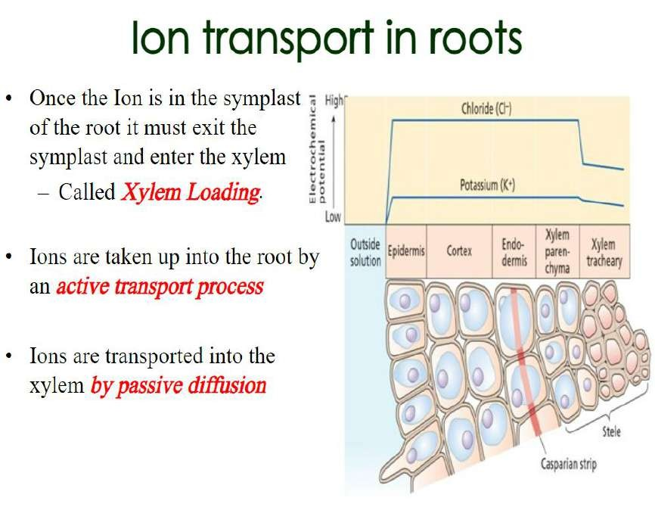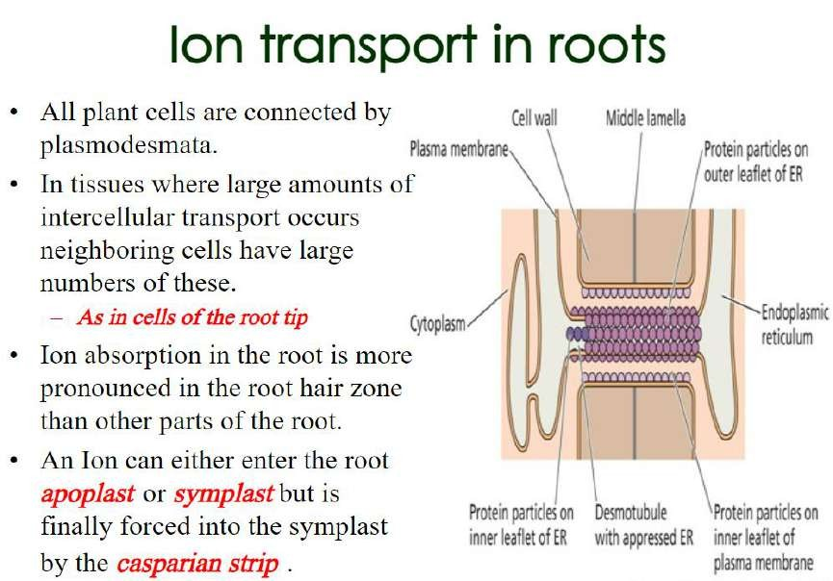

Water transport in roots

Three ways of water transport. (a) Water is transported through a simple channel, driven by osmotic driving force.
- Water is cotransported with substrate through a cotransporter that is bimodal, a passive component transport and a secondary active component transport.
- Water is transported by a pump that actively transports water across membranes relying on ATP hydrolysis

